Remove spaces from a given string
Given a string of characters consisting of 0 or more spaces, remove all the spaces from this given string. Separation of spaces from other characters should be done in-place(without using extra space). Expected time complexity is O(n).
For example, if the input string is " Hi, How are you? " then the output returned should be "Hi,Howareyou?"

Algorithm/Insights
For a given string, if there are 'j' number of spaces to the left of the character at index 'i', then that 'i'th character would be placed at (i-j)th index after removing all spaces from the given string.
Using above idea, all we do is traverse the given string from the leftmost character and keep counting the number of spaces seen so far. If the current character at index 'i' is a non-space character and if there are 'j' number of spaces seen so far then we copy 'i'th character to index (i-j). Note that because we are traversing this string from the leftmost end, character at index (i-j) would already have been placed in its correct position and therefore we don't need to worry about overwriting it. Following example should help you to visualize this step.
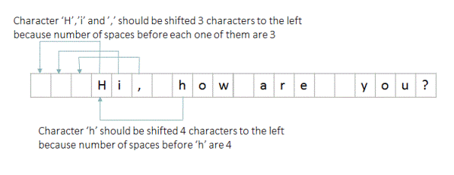
After the traversal of complete string, we would have counted the total number of spaces in the given string, let that be 'numSpaces'. Now all we do is remove the last 'numSpaces' characters of this string by copying characters of this modified string from index 0 to index (lengthOfString - numSpaces - 1) including both extremes into a new string. You can refer to function 'removeSpaces(String str)' for implementation details.
Please note that in the Java programming language, unlike C, an array of char is not a String, and neither a String nor an array of char is terminated by '\u0000' (the NUL character). Reference: https://docs.oracle.com/javase/specs/jls/se7/html/jls-10.html#jls-10.9 . Therefore we have to copy the modified string into a new string which would take O(n) extra space.

package com.ideserve.nilesh.questions;

import java.util.Arrays;

/**
* <b>IDeserve <br>
* <a href="https://www.youtube.com/c/IDeserve">https://www.youtube.com/c/IDeserve</a>
* Removes spaces from a given string in O(n) time.
* @author Nilesh
*/

public class RemoveSpaces
{
// removes spaces from given string
public static String removeSpaces(String str)
{
char[] charArray = str.toCharArray();

int numSpaces = 0; // number of spaces before 'i'th character
for (int i = 0; i < charArray.length; i++)
{
// count number of spaces
if (charArray[i] == ' ')
{
numSpaces += 1;
}
// put 'i'th character into its correct position after removing spaces before it
else
{
charArray[i-numSpaces] = charArray[i];
}
}

// all the spaces are moved towards the end of the string.
// Create new string by using non-space characters
charArray = Arrays.copyOf(charArray, charArray.length - numSpaces);

return new String(charArray);
}

public static void main(String[] args)
{
String strWithSpaces = " Hi there, how are you doing? ";
String strWithoutSpaces = removeSpaces(strWithSpaces);

System.out.println(strWithoutSpaces);
}
}

Longest Substring with non-Repeating Characters
Given a string, find the longest substring with non-repeating characters.
Example:
Input : ABCDABDEFGCABD
Output: ABDEFGC

Algorithm/Insights
Method 1: Naive Algorithm
Check for every substring whether it is has repeating characters. If not, then check if it is longest substring or not.
Time complexity: O(n^3)
Space Complexity: O(1)
Method 2: Linear time Algorithm
1. Create an array charIndexes which has last index of string characters seen in the string, initialized to -1
2. Traverse the array and check if current character was seen earlier in the current sub-array, if not seen then increment index of current non repeating substring seen till now(currLength).
3. If the current character is a repeated character and length of longest substring (maxLength) seen till now is less than current length, then update maxLength.
Time complexity: O(n)
Space Complexity: O(1)

Code Snippet
package com.ideserve.questions.saurabh;

/**
* <b>IDeserve <br>
* <a href="https://www.youtube.com/c/IDeserve">https://www.youtube.com/c/IDeserve</a>
* Longest substring without repeating characters
*
* @author Saurabh
*/
public class LongestSubstring {

// Naive algorithm for finding the longest substring without repeating characters
// Quadratic time complexity
public static String getLongestSubstringNonRepeatingCharsNaive(String str) {
String longestSubstring = "";
for(int i = 0; i < str.length(); i++) {
for(int j = i; j < str.length(); j++) {
if(hasRepeatingChars(str, i, j)) {
break;
} else if(longestSubstring.length() < j-i+1){
longestSubstring = str.substring(i, j+1);
}
}
}
return longestSubstring;
}

private static boolean hasRepeatingChars(String str, int start, int end) {
boolean[] isCharPresent = new boolean[256];
for(int i = 0; i < 256; i++) {
isCharPresent[i] = false;
}
for(int i = start; i <= end; i++) {
if(isCharPresent[str.charAt(i)]) {
return true;
} else {
isCharPresent[str.charAt(i)] = true;
}
}
return false;
}

// Linear time algorithm for finding the longest substring without repeating characters
public static String getLongestSubstringNonRepeatingChars(String str) {

if(str == null) {
return null;
}

int n = str.length();
if(n < 2) {
return str;
}

// array to store last index of string characters seen in the string, initialized to -1
int[] charIndexes = new int[256];
for(int i = 0; i < n; i++) {
charIndexes[i] = -1;
}

// Set index of first character
charIndexes[str.charAt(0)] = 0;

int currLength = 1; // Length of current non repeating substring
int maxLength = 1; // Length of longest substring with non repeating characters found
int prevIdx = 0; // previous index of current character
int startIdx = 0; // Starting index of longest substring with non repeating characters found

for(int i = 1; i < n; i++) {
prevIdx = charIndexes[str.charAt(i)];
if(prevIdx == -1 || i - currLength > prevIdx) {
currLength++;
} else {
if(currLength > maxLength) {
maxLength = currLength;
startIdx = i - maxLength;
}
currLength = i - prevIdx;
}
charIndexes[str.charAt(i)] = i;
}

// Check if longest substring with non repeating characters ends at end of the string
if(currLength > maxLength) {
maxLength = currLength;
startIdx = n - maxLength;
}

return str.substring(startIdx, startIdx + maxLength);
}

public static void main(String[] args) {
String str = "ABCDABDEFGCABD";
/*String longestSubstring = getLongestSubstringNonRepeatingCharsNaive(str);
System.out.println("Longest substring non repeating chars by Naive method:\t\t" + longestSubstring);*/
String longestSubstring = getLongestSubstringNonRepeatingChars(str);
System.out.println("Longest substring non repeating chars by linear time method:\t" + longestSubstring);

}
}

Order of the Algorithm
Time Complexity is O(n)
Space Complexity is O(1)

Check balanced parentheses in a string

Given a string with parentheses (round brackets) and letters, validate the parentheses:
1. An opening parentheses '(' should have a closing matching parentheses ')'.
2. Closing matching parentheses should not come before an opening parentheses.
Note: Assume that the string has alphabets and numbers and round brackets only.
For example:
((BCD)AE) - Valid
)(PH)N(X) – Invalid

Algorithm/Insights
- Iterate over the string.
2. Create count = 0, increment count if an opening parentheses is seen, decrement count if a closing parentheses is seen.
3. If when a closing parentheses is seen and count is 0, then it means that the current closing parentheses does not have a matching opening parentheses, so return false.
4. When iteration completes, if count is not 0, it means there is an opening parentheses without a matching closing parentheses, so return false.
5. If count is 0, return true.
We will create a separate post for validating an expression having multiple types of parentheses (round brackets (), curly brackets {}, square brackets [] etc)
public class Parentheses {

public static boolean isValid(String str) {

if (str == null || str.length() == 0) {
return true;
}

int count = 0;
int i = 0;
while (i < str.length()) {
char ch = str.charAt(i);
if (ch == '(') {
count++;
} else if (ch == ')') {
if (count == 0)
return false;
else
count--;
}
i++;
}

if(count != 0)
return false;

return true;
}

public static void main(String[] args) {
String str = "((BCD)AE)";
System.out.println("isValid: " + isValid(str));
str = ")(PH)N(X)";
System.out.println("isValid: " + isValid(str));
}
}

Order of the Algorithm
Time Complexity is O(n)
Space Complexity is O(1)

Postfix Expression Evaluation
Evaluate the value of a Postfix expression, also known as expression in Reverse Polish Notation.
Given: An array of strings, every string being either an operand or an operator, in Reverse Polish Notation, find out the value of the expression.
Assumptions: The given postfix expression will be a valid expression.
1. String operands will be valid Integers (positive or negative)
2. Operators will be valid operators in: + - / *
3. 0 will not be passed as a divisor for division operation.
Example:
Input:
20 30 +
Output:
50
Input:
5 1 2 + 4 * + 3 -
Output:
14
Note: Input is an array of strings to allow numbers with multiple digits as operands.
For example "20", "45" etc.

Algorithm/Insights
Reverse Polish notation (RPN) is a mathematical notation in which every operator is placed after its operands. For example, x + y (in infix notation) is expressed in RPN as x y +
It is also known as postfix notation.
The expression can be evaluated using a stack as described below:
1. If the array has only 1 element, then return the element.
2. Traverse the string array for elements i = 0 to length of array:
a. If the element at index i is an operand, then parse it to get the value.
b. Else, pop two elements from the stack (say x and y) and perform the operation specified by the operator (for example, +) on the 2 elements in the below order and store it as the value:
y = s.pop()
x = s.pop()
value = x + y
c. We will get a value from steps a OR b, push the value on to the stack.
3. Finally, only 1 integer element is left on the stack, return it.
Example:
String Array: 5 1 2 + 4 * + 3 -
1. Initialize empty stack.
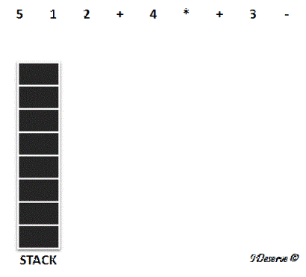
2. Since 5 is an operand, add it to the stack.
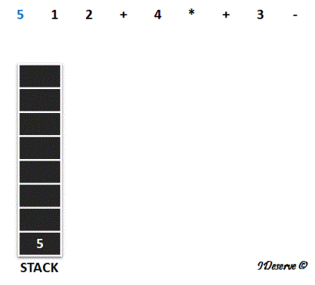
3. 1 and 2 are also operands, so add these to the stack too.
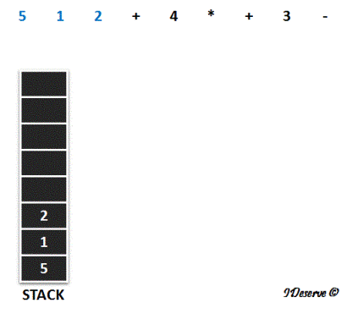
4. Next we have + operator,
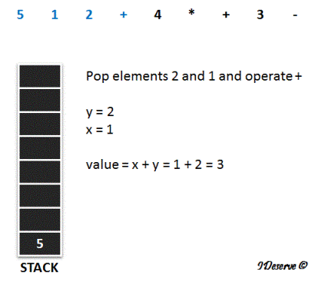
5. Push the value onto the stack.
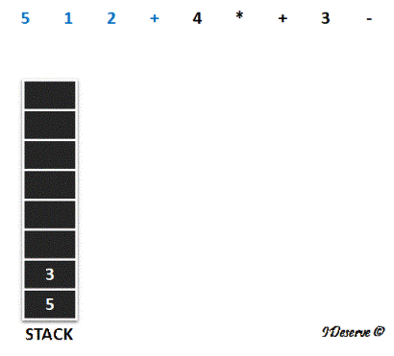
6. Next we have 4, which is an operand, so push it to the stack
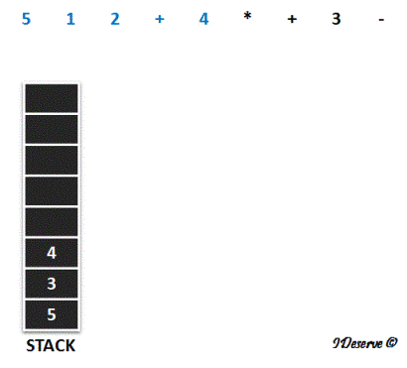
7. Next we have * operator,
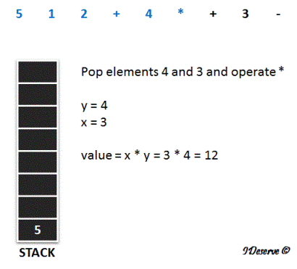
8. Push the value onto the stack
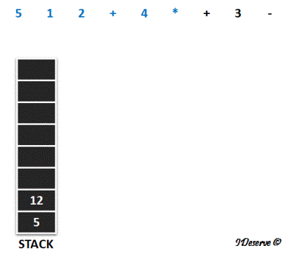
9. Next we have + operator,
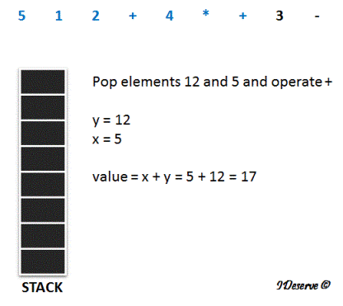
10. Push the value 17 onto the stack
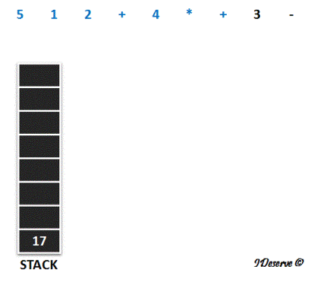
11. Next element is an operand 3, push it to the stack
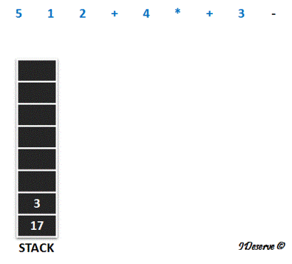
12. Last, we have - operator,
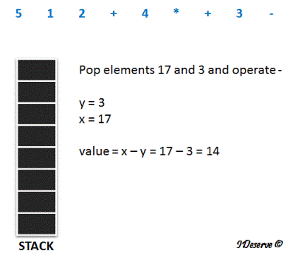
Finally, all the array elements are processed, and we have 14 as the result.

Group all anagrams together from a given array of strings | Set 1
Given an array of strings, sort the array in such a way that all anagrams are grouped together. For example, if the given array input is {"abcd","abc","abce", "acd","abdc"} then output array should be {"abc","abcd","abdc","abce","acd"}. Note that order among non-anagram strings is not important here. Instead of returning above array as output, your program could have returned an array having different order of strings but strings "abcd" and "abdc" must be placed next to each other with no specific ordering requirement among them. So the output array - {"abdc","abcd","abc","abce","acd"} would also be a correct output.

Algorithm/Insights
The idea to sort string array in order to group anagrams together is simple. A regular sort method on string array would put all strings in their increasing alphabetical/dictionary order. We change this order by implementing a custom comparator in which instead of comparing two strings 'S1' and 'S2' directly, we compare the sorted versions of 'S1' and 'S2'. This sorted version comparison makes sure that if 'S1' and 'S2' are anagrams of each other then they would be placed next to each other in sorted array (since custom compare method would return 0).
For implementing a custom Comparator, our java class must implement 'compare(Object obj1, Object obj2)' method of Comparator interface with its object type as String. In the implementation of 'compare(String S1, String S2)' method, all that needs to be done is to sort both strings S1 and S2 and then return the result of their comparison. If they are anagrams of each other, 0 would be returned.
Note that implementing 'compare(Object obj1, Object obj2)' method of Comparator interface makes our java class a Comparator. And then this Comparator can be passed to a sort method (Arrays.sort) to allow precise control over the sort order. Please checkout class AnagramSort in code snippet for implementation details. We need to make call - Arrays.sort(strArray, new AnagramSort()) to sort array which does grouping of anagrams.
The time complexity of this algorithm is O(nlogn) where n is the size of the input string array. Its space complexity is O(n). This is because Arrays.sort uses mergesort for sorting as specified in java 7 documentation. Here is the relevant excerpt from documentation of this method - "Implementation note: This implementation is a stable, adaptive, iterative mergesort that requires far fewer than n lg(n) comparisons when the input array is partially sorted"
package com.ideserve.questions.nilesh;

import java.util.Arrays;
import java.util.Comparator;

public class AnagramSort implements Comparator<String>
{
public String sortChars(String s)
{
char[] content = s.toCharArray();
Arrays.sort(content);
return new String(content);
}

@Override
// compares its two argument strings for order
public int compare(String s1, String s2)
{
return sortChars(s1).compareTo(sortChars(s2));
}

public static void main(String[] args)
{
String[] strArray = {"abcd","abc","abce", "acd","abdc"};

Arrays.sort(strArray, new AnagramSort());

for (int i = 0; i < strArray.length; i++)
{
System.out.println(strArray[i]);
}
}
}

First non-repeating character in a string
Find the first non repeating character in string.
Example:
Input : ADBCGHIEFKJLADTVDERFSWVGHQWCNOPENSMSJWIERTFB
Output: K

Algorithm/Insights
Solution 1:
Naive Solution: Use 2 loops to check for every character whether it is non-repeating or not. Return the first such character found.
Linear Solution 1: Use a count array to store the count of every character.
1. Create a count array.
2. Initialize count of every element to 0.
3. Traverse the string once and increment the count of every element found in the string.
4. Traverse the string again and check for the first element for which count is set as 1. Return this element.
5. If not found, return null
If string is large, traversing string again to find first element whose count is 1, is inefficient.
Linear Solution 2 (Optimized): Use index array for storing the index of the string elements.
1. Create an index array.
2. Initialize the index of all index array elements to -1.
3. Traverse the string once and for element of the string, check the value of index of that string element in index array.
a. If index is -1, it is the first occurrence in the string. Set index[string.charAt(i)] = i
b. Else, the element is repeating, set index[string.charAt(i)] = -2
4. Traverse the index array once, find the minimum value in the array which is non negative. If found, this is the index of the first non repeating character in the string.
Else, return null.
public class FirstNonRepeatingCharacter {

public static Character getFirstNonRepeatingCharacterLinearOptimized(String string) {
if(string == null || string.length() == 0) {
return null;
}

int n = string.length();
if(n == 1) {
return string.charAt(0);
}

int[] charIdx = new int[256]; // Index of non repeating characters. If repeating, then index = -2
// Initialize character index of all characters to -1
for(int i = 0; i < 256; i++) {
charIdx[i] = -1;
}

for(int i = 0; i < n; i++) {
if(charIdx[string.charAt(i)] == -1) {
// character seen first time
charIdx[string.charAt(i)] = i;
} else {
// Repeated character
charIdx[string.charAt(i)] = -2;
}
}

int minIdx = n; // Index of first non repeating character
for(int i = 0; i < 256; i++) {
if(charIdx[i] >= 0 &&
minIdx > charIdx[i]) {
minIdx = charIdx[i];
}
}
return (minIdx >= 0 && minIdx < n) ? string.charAt(minIdx) : null;
}

public static Character getFirstNonRepeatingCharacterLinear(String string) {
if(string == null || string.length() == 0) {
return null;
}

int n = string.length();
if(n == 1) {
return string.charAt(0);
}

int[] charCounts = new int[256];
// Initialize character counts of all characters to 0
for(int i = 0; i < 256; i++) {
charCounts[i] = 0;
}

for(int i = 0; i < n; i++) {
charCounts[string.charAt(i)]++;
}

for(int i = 0; i < n; i++) {
if(charCounts[string.charAt(i)] == 1) {
return string.charAt(i);
}
}
return null;
}

public static Character getFirstNonRepeatingCharacterNaive(String string) {
if(string == null || string.length() == 0) {
return null;
}

int n = string.length();
for(int i = 0; i < n; i++) {
boolean flag = true;
for(int j = 0; j < n; j++) {
if(i != j && string.charAt(i) == string.charAt(j)) {
flag = false;
break;
}
}
if(flag) {
return string.charAt(i);
}
}
return null;
}

public static void main(String[] args) {
String string = "ADBCGHIEFKJLADTVDERFSWVGHQWCNOPENSMSJWIERTFB";
System.out.println("Output: " + getFirstNonRepeatingCharacterLinearOptimized(string));
}
}

Order of the Algorithm
Time Complexity is O(n)
Space Complexity is O(1)

Find all permutations of a String

Given a string, find all the permutations of the string.
For example:
Input String: abc
Output: {bca, acb, abc, cba, bac, cab}

Algorithm/Insights
1. We use a hash set to store all permutations of the string.
2. If string is null or of 0 length, we return a hashset with "" as element
3. We keep first character of the string and recursively call getAllPermutations on the remaining string.
4. When the function returns, we add the first character to all positions in all the strings that we got in the hashset.
Please see algorithm visualization to test the algorithm with sample data.
public class AllPermutationsString {

public static HashSet<String> getAllPermutations(String str) {
// Create a hash set to prevent any duplicate entries
HashSet<String> permutations = new HashSet<String>();

if(str == null || str.length() == 0) {
permutations.add("");
return permutations;
}

char first = str.charAt(0);
String remainingString = str.substring(1);
HashSet<String> words = getAllPermutations(remainingString);
for(String word: words) {
for(int i = 0; i <= word.length(); i++) {
String prefix = word.substring(0, i);
String suffix = word.substring(i);
permutations.add(prefix + first + suffix);
}
}
return permutations;
}

public static void main(String[] args) {
String str = "abc";
HashSet<String> permutations = getAllPermutations(str);
System.out.println(permutations.toString());
}

Word Break Problem
Given a dictionary of words and a string of characters, find if the string of characters can be broken into individual valid words from the dictionary.
Example:
Dictionary: arrays, dynamic, heaps, IDeserve, learn, learning, linked, list, platform, programming, stacks, trees
String : IDeservelearningplatform
Output : true
Because the string can be broken into valid words: IDeserve learning platform

Algorithm/Insights
The given problem can be solved by using Dynamic Programming as described below:
1. Create a temporary boolean array validWords[] defined as:
validWords[i]
= true, if input substring from 0 to i forms valid words string
= false, otherwise
2. For i = 0 to input.length,
a. If input substring from 0...i is present in the dictionary, then set validWords[i] = true
b. If validWords[i] == true, from j = i+1 to n-1, check if substring from i+1 to j, for all values of j (= i+1 to n-1), is present in the dictionary and set validWords[j] to true if found in the dictionary.
3. When we reach the end of the string, if validWords[n-1] is true, then return true else return false.
Example:
Consider the dictionary:
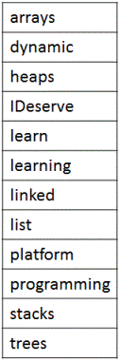
Input string:
IDeservelearningplatform
Temporary array validWords[] initialized to false (represented by F in the image).
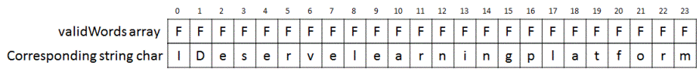
i = 0:
Is input substring from 0...i (= I) present in the dictionary? ✖
i = 1:
Is input substring from 0...i (= ID) present in the dictionary? ✖
i = 2:
Is input substring from 0...i (= IDe) present in the dictionary? ✖
Proceeding till i = 6:
Is input substring from 0...i (= IDeserv) present in the dictionary? ✖
i = 7:
Is input substring from 0...i (= IDeserve) present in the dictionary? ✔
Set validWords[i] = true (represented by T in the image)
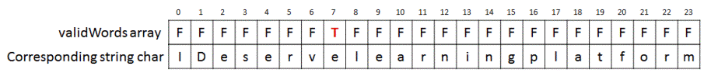
Next, starting from j = i+1 to n-1, on checking for all substrings from i+1 to j, we see that 'learn' (ending at j=12) and 'learning' (ending at 15) form valid dictionary words.
So we set, validWords[12] = true and validWords[15] = true.
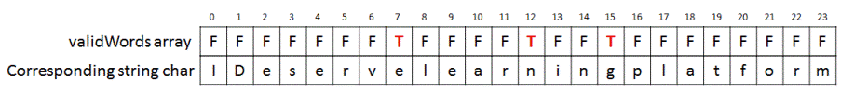
Since, we have not reached the end of the input string, we proceed with next steps.
i = 8:
Is input substring from 0...i (= IDeservel) present in the dictionary? ✖
Proceeding till i = 11:
Is input substring from 0...i (= IDeservelear) present in the dictionary? ✖
i = 12: input substring = IDeservelearn
validWords[i] is already true.
Next, starting from j = i+1 to n-1, on checking for all substrings from i+1 to j, we see that there is no valid dictionary word found.
Proceeding like before for i = 13 and 14:
Is input substring from 0...i (= IDeservelearni) present in the dictionary? ✖
Is input substring from 0...i (= IDeservelearnin) present in the dictionary? ✖
i = 15: input substring = IDeservelearning
validWords[i] is already true.
Next, starting from j = i+1 to n-1, on checking for all substrings from i+1 to j, we see that 'platform' (ending at 23) is a valid dictionary word.
So, we set validWords[23] = true.
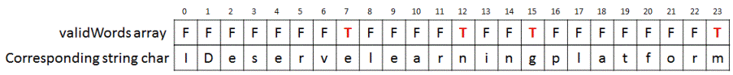
Since, we have reached end of string and validWords[n-1] = validWords[23] = true, hence we return true.
public class WordBreakProblem {

private static final Set<String> dictionary = new HashSet<String>(Arrays.asList("arrays", "dynamic", "heaps", "IDeserve", "learn", "learning", "linked", "list", "platform", "programming", "stacks", "trees"));

public static boolean hasValidWords(String words) {

// Empty string
if(words == null || words.length() == 0) {
return true;
}

int n = words.length();
boolean[] validWords = new boolean[n];
for (int i = 0; i < n; i++) {
if (dictionary.contains(words.substring(0, i + 1))) {
validWords[i] = true;
}
if (validWords[i] == true && (i == n - 1))
return true;
if (validWords[i] == true) {
for (int j = i + 1; j < n; j++) {
if (dictionary.contains(words.substring(i + 1, j + 1))) {
validWords[j] = true;
}
if (j == n - 1 && validWords[j] == true) {
return true;
}
}
}
}
return false;
}

public static void main(String[] args) {
if (hasValidWords("IDeservelearningplatform"))
System.out.println("true");
else
System.out.println("false");
}
}

Subset Sum Problem
Detect if a subset from a given set of N non-negative integers sums upto a given value S.
Example:
Set: {1, 3, 9, 2}, S = 5
Output: true

Shortest Palindrome
Given a string s, form a shortest palindrome by appending characters at the start of the string.
Example: abab => babab. abcd => dcbabcd. ananab => banana
public class ShortestPalindrome {

public static String shortestPal(String s)
{
String rev_s = new StringBuilder(s).reverse().toString();
//use special character to avoid overlap
String l = s + "#" + rev_s;

int[] p = new int[l.length()];

//build KMP table.
//i -> suffix boundary
//j -> prefix boundary

for(int i=1; i<l.length(); i++)
{
//update prefix boundary to previous match position
int j = p[i-1];

//move to the last prefix boundary match
while(j>0 && l.charAt(i)!=l.charAt(j))
j = p[j-1];

//if prefix boundary matches suffix boundary,
//increase prefix length
if(l.charAt(i) == l.charAt(j)) p[i] = j + 1;
}

return rev_s.substring(0, s.length() - p[l.length() - 1]) + s;
}

public static void main(String args[])
{
System.out.println(shortestPal("abab"));
}

To print maximum number of As using four keys of special keyboard.
Let us assume that we have a specially made keyboard which has following four keys:
Key 1: This key prints character 'A' on the output screen
Key 2: (Ctrl-A): This keys selects the complete contents of the screen - same function as (Ctrl + A) of PC
Key 3: (Ctrl-C): This key copies the seleceted content to buffer or clipboard - same function as (Ctrl + C) of PC
Key 4: (Ctrl-V): This key appends saved contents of buffer/clipboard to the output screen.
If you are allowed to press keys of this special keyboard N times, write a program which calculates maximum numbers of As possible.
Example -
Input: N = 3
Output: 3
Maximum number of As possible with 3 keystrokes is 3 which are obtained by using following key sequence -
A, A, A
Input: N = 8
Output: 12
Maximum number of As possible with 8 keystrokes is 9 which are obtained by using following key sequence -
A, A, A, Ctrl A, Ctrl C, Ctrl V, Ctrl V, Ctrl V
OR following keysequence also produces 12 As
A, A, A, A, Ctrl A, Ctrl C, Ctrl V, Ctrl V
Input: N = 12
Output: 36
Maximum number of As possible with 12 keystrokes is 36 which are obtained by using following key sequence -
A, A, A, A, Ctrl A, Ctrl C, Ctrl V, Ctrl V, Ctrl A, Ctrl C, Ctrl V, Ctrl V

word
public class MaxNumberOfAs
{
// assuming max input for 'n' won't be greater than 10.
// you might want to change it according to your need.
private static int MAX = 10;

/*
* f(N) = N if N < 7
* = max{2*f(N-3), 3*f(N-4),..., (N-2)*f(1)}
*/
public static int findMaxAs(int n, int[] maxAsSolution)
{
// base case
if (n < 7) return n;

int maxSoFar = 0, maxAsWithThis_i = 0, multiplier = 2;

// choose the critical point which produces maximum number of As
for (int i = n-3; i >=0; i--)
{
// make recursive call if required
if (maxAsSolution[i] == -1)
{
maxAsSolution[i] = findMaxAs(i, maxAsSolution);
}

maxAsWithThis_i = multiplier*maxAsSolution[i];

if(maxAsWithThis_i > maxSoFar)
{
maxSoFar = maxAsWithThis_i;
}
multiplier +=1;
}
return maxSoFar;
}

public static void main (String[] args) throws java.lang.Exception
{
// assuming input n won't be greater than 10.
int [] maxAsSolution = new int[MAX];
for (int i = 0; i < maxAsSolution.length; i++)
{
// maxAsSolution[i] = -1 indicates that solution for this input = 'i' is not computed yet.
maxAsSolution[i] = -1;
}

// find max number of As with 8 keystrokes allowed.
System.out.println("Max number of As possible with 8 keystrokes: " + findMaxAs(8, maxAsSolution));
}
}

Minimum number of trials to reach from source word to destination
Given a dictionary of words, find minimum number of trials to reach from source word to destination word. A valid trial on word 'w' is defined as either insert, delete or substitute operation of a single character in word 'w' which results in a word 'w1' which is also present in the given dictionary. For example, for dictionary {"BCCI","AICC","ICC","CCI","MCC","MCA", "ACC"}, minimum number of trials to reach from word "AICC" to "ICC" is 1. Only 1 opeartion of deleting character 'A' is required to reach from word "AICC" to word "ICC". Minimum number of trials to reach from "AICC" to "MCC" is 2(AICC->ICC->MCC) and minimum number of trials to reach from "AICC" to "MCA" is 3(AICC->ICC->MCC->MCA).
Now if you notice, there are no valid trials with source as "AICC" and destination as "BCCI" for above dictionary. Hence the output returned by program should be '-1' indicating destination word cannot be reached from source word.

Algorithm/Insights
The valid trial on a word is nothing but an edit operation consisting of either edit or delete or insert operation which results in another word present in given dictionary of words.
Using this definition of valid trial, we can re-model this problem as a graph problem where nodes are created for representing all words in dictionary. If edit distance between two words 'word0' and 'word1' is 1, then an edge is added with cost as 1 between nodes 'n0' and 'n1' representing words 'word0' and 'word1' respectively.
Now to find out the minimum number of trials to reach from 'source' word to 'destination' word, all we need to do is to find out the minimum distance between node representing 'source' word and node representing 'destination' word. Because in this graph, all edges have equal cost of 1, doing a breadth first search or depth first search for 'destination' node starting from 'source' node is sufficient to compute minimum distance between 'source' node and 'destination' node. This minimum distance obtained is nothing but the number of trials required to reach 'destination' word from 'source' word.
Example: If we are asked to find out the minimum number of trials to reach from word "AICC" to word "MCA" for dictionary {"BCCI","AICC","ICC","CCI","MCC","MCA", "ACC"}, then we first create a graph with edges between those nodes which have edit distance of 1 between them. The graph created would look like following -
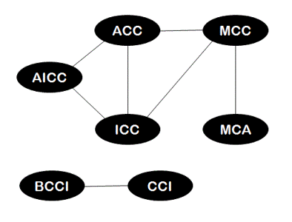
Please note that this graph has two connected components where every node in a component is reachable from every other node. The edges in this graph are bi-directional and hence no direction arrows are shown.
To find out the minimum number of trials to reach from "AICC" to "MCA", we simply start breadth first search from node "AICC" in above graph until we reach node "MCA". While doing breadth first search, starting node "AICC" is assumed to be at level-0, all its neighbors then would be at level-1, neighbors of immediate neighbor of "AICC" would be at level-2 and so on. While doing breadth first search, we keep track of the level of each node visited. During breadth first search, at level-0 only node "AICC" would be visited. At level-1, nodes "ACC" and "ICC" would be visited. Node "MCC" would be visited at level-2 and finally when node "MCA" is visited at level-3, its level that is level-3 is returned since this level would be equal to the minimum number of trials required to reach node "MCA" from node "AICC".
The time complexity of this algorithm is O(m^2.n^2) where 'm' is total number of words in given dictionary and 'n' is the average length of each word. This is because while constructing graph, there are O(m^2) pairs of words for which edit distance is calculated in O(n^2) time. Note that time taken for breadth first search is O(|E|) = O(m^2) in the worst case which is less than time taken for graph building and hence this time is ignored while computing overall time complexity.
public class MinimumTrialsSourceToDestWord<T>
{
// used for breadth first search
private class QueueNode
{
GraphNode graphNode;
int level;

// this constructor is used while doing breadth first traversal
public QueueNode(GraphNode node, int level)
{
this.graphNode = node;
this.level = level;
}
}

private class GraphNode
{
T nodeId;
GraphNode next;
int parentDist;

GraphNode(T id)
{
nodeId = id;
next = null;
}

GraphNode(T id, int dist)
{
nodeId = id;
next = null;
parentDist = dist;
}
}

HashMap<T, GraphNode> nodeList;

// create an empty nodelist for holding nodes of graph
public MinimumTrialsSourceToDestWord()
{
nodeList = new HashMap<T, GraphNode>();
}

private void addNode(T id)
{
GraphNode node = new GraphNode(id);
nodeList.put(id, node);
}

private void addEdge(T id1, T id2, int dist)
{
GraphNode node1 = nodeList.get(id1);
if (node1 == null)
{
return;
}
GraphNode node2 = new GraphNode(id2, dist);

node2.next = node1.next;
node1.next = node2;
}

// find the node with required nodeId in graph's node list.
private GraphNode findGraphNode(T nodeId)
{
return nodeList.get(nodeId);
}

// prints adjacency list representation of the graph
public void printGraph()
{
Iterator<T> nodeIterator = nodeList.keySet().iterator();

while (nodeIterator.hasNext())
{
GraphNode curr = nodeList.get(nodeIterator.next());

while (curr != null)
{
System.out.print(curr.nodeId+"("+curr.parentDist+")"+"->");
curr = curr.next;
}
System.out.print("Null");
System.out.println();
}
}

private static int min(int a, int b)
{
return (a<b)?a:b;
}

private static int min(int a, int b, int c)
{
return min(min(a,b),c);
}

// find minimum edit distance between str1 and str2
private static int editDistance(String str1, String str2)
{
// if either of the strings is null, distance cannot be computed
if (str1 == null || str2 == null)
{
return -1; // indicates error input
}

// all values are by default initialized to 0 by JVM
int[][] distanceTable = new int[str1.length()+1][str2.length()+1];

int numRows = str1.length() + 1;
int numCols = str2.length() + 1;

for (int m = 0; m < numRows; m++)
{
for (int n = 0; n < numCols; n++)
{
// if length of str1 is 0, we have no option but to insert all of str2
if (m == 0)
{
distanceTable[m][n] = n;
}

// if length of str2 is 0, delete all of str1 of make it match with str2
else if (n == 0)
{
distanceTable[m][n] = m;
}

/*
* if last characters of str1 and str2 are equal, compute distance ending at
* second last characters for both str1 and str2
*/
else if (str1.charAt(m-1) == str2.charAt(n-1))
{
distanceTable[m][n] = distanceTable[m-1][n-1];
}

/*
* else use minimum of following three cases:
* delete last character of str1 and check distance: distance(str1, str2, m-1, n)
* insert last character of str2 into str1 and check distance: distance(str1, str2, m, n-1)
* replace last char of str1 with last char of str2 and check distance: distance(str1, str2, m-1, n-1)
*/
else
{
distanceTable[m][n] = min (
1 + distanceTable[m-1][n],
1 + distanceTable[m][n-1],
1 + distanceTable[m-1][n-1]
);
}
}
}

return distanceTable[numRows-1][numCols-1];
}

/*
* Does a breadth first traversal of a given graph starting from node with id = srcId.
*/
public int breadthFirstSearch(T srcId, T destId)
{
if (nodeList.isEmpty())
{
System.out.println("Empty graph");
return -1;
}

// queue used during the traversal
LinkedList<QueueNode> queue = new LinkedList();

// keeps track of node which are visited and added into the queue
HashMap<T, Integer> visited = new HashMap();

// find srcNode with id = srcId in graph
GraphNode srcNode = nodeList.get(srcId);

// if srcNode is not there in graph, breadth first traversal which starts at srcNode cannot be done
if (srcNode == null)
{
System.out.println("Source vertex not found");
return -1;
}

int minNumberTrials = -1;

// add srcNode in queue, mark it as visited
queue.add(new QueueNode(srcNode, 0));
visited.put(srcNode.nodeId, 1);

while (!queue.isEmpty())
{
QueueNode currentNode = queue.remove();

// if destination node found
if (currentNode.graphNode.nodeId == destId)
{
minNumberTrials = currentNode.level;
break;
}

// first neighbor of current graph node
GraphNode neighbor = currentNode.graphNode.next;

// add all neighbors of current graph node into the queue
while (neighbor != null)
{
// if this neighbor is not visited earlier, mark it as visited
// add it to the queue at appropriate level
if (visited.get(neighbor.nodeId) == null)
{
visited.put(neighbor.nodeId, 1);
queue.add(new QueueNode(findGraphNode(neighbor.nodeId), currentNode.level + 1));
}
neighbor = neighbor.next;
}
}

return minNumberTrials;
}

// add edges for those strings which have edit distance of 1.
public static void createGraph(MinimumTrialsSourceToDestWord graph, String[] dictionary)
{
// creates nodes: one for each string in the list
for (int i = 0; i < dictionary.length; i++)
{
graph.addNode(dictionary[i]);
}

// add edges only between the nodes which have distance of 1 between them
for (int i = 0; i < dictionary.length; i++)
{
for (int j = 0; j < dictionary.length; j++)
{
if (editDistance(dictionary[i], dictionary[j]) == 1)
{
graph.addEdge(dictionary[i], dictionary[j], 1);
}
}
}
}

public static void main(String[] args)
{
MinimumTrialsSourceToDestWord<String> solution = new MinimumTrialsSourceToDestWord();

String[] dictionary = {"BCCI","AICC","ICC","CCI","MCC","MCA", "ACC"};

createGraph(solution, dictionary);

// prints adjacency list representation of this graph.
// solution.printGraph();

String srcNodeId = "AICC", destNodeId = "MCA";

System.out.print("Minimum number of trials to reach from source word to destination word:\n");

// search destination node from source node using breadth first search
System.out.print(solution.breadthFirstSearch(srcNodeId, destNodeId));
}
}

Order of the Algorithm
Time Complexity is O(m^2.n^2) where m is number of words and n is the average length of word
Space Complexity is O(n^2)

Finding 10 letter repeated DNA sequences.

A DNA is composed of a series of nucleotides abbreviated as A, C, G, and T, for example: 'ACGAATTCCG'.
Write a function to find all the 10-letter-long sequences(sub-strings) that occur more than once in a DNA molecule.
Example - Input: 'AAAAACCCCCAAAAACCCCCCAAAAAGGGTTT', Expected Output: [AAAAACCCCC,CCCCCAAAAA]

Algorithm/Insights
A naive approach of sliding the 10-letter window across the given sequence combined with hashmap would take O(n^2) time.
Using rolling hash method takes O(n) time. Here are the steps.
1. Compute hash value for the sequence in the first window.
2. Store the computed value in a set/hashmap.
3. Compute hash values for subsequent sequence(which would be sequence obtained by sliding 10-letter window to the right by one character) using rolling hash method.
Rolling hash method makes use of hash value computed for previous sequence to compute hash value for current sequence.
4. If computed hash value is already present in the hashmap then add the current sequence to output set, else store the computed value in the hashmap. .
5. Repeat step #3, #4 until all the 10-letter sequences are completed.
Rolling Hash computation uses following method. For details and intuition, please check out the video.
currHash = prevHash - val(skippedChar)*2^10
currHash = currHash * 2
currHash = currHash + 2*val(newChar)
public class RepeatedDnaSequencesSolution
{
private static final Map<Character, Integer> encodings = new HashMap<>();
static { encodings.put('A',0); encodings.put('C',1); encodings.put('G',2); encodings.put('T',3); }
private final int Two_POW_9 = (int) Math.pow(2, 9);

public List<String> findRepeatedDnaSequences(String s) {

Set<String> res = new HashSet<>();
Set<Integer> hashes = new HashSet<>();
List<String> solution = new ArrayList<String>();

HashMap duplicates = new HashMap<Integer, String>();

for (int i = 0, rhash = 0; i < s.length(); i++)
{
if (i > 9) rhash -= Two_POW_9 * encodings.get(s.charAt(i-10));

rhash = 2 * rhash + encodings.get(s.charAt(i));

if (i > 8)
{
if (duplicates.get(rhash) != null)
{
res.add(s.substring(i-9,i+1));
}
else
{
duplicates.put(rhash, "");
}
}
}
return new ArrayList<>(res);
}

public static void main(String[] args)
{
RepeatedDnaSequencesSolution sln = new RepeatedDnaSequencesSolution();
List<String> list = sln.findRepeatedDnaSequences("AACAAAAACAAAACCAAAAACAAAAACAAAA");

System.out.println("Repeated DNA sequences are: ");
for (int i = 0; i < list.size(); i++)
{
System.out.println(list.get(i));
}
}

Find minimum edit distance between given two strings
Minimum Edit distance between two strings str1 and str2 is defined as the minimum number of insert/delete/substitute operations required to transform str1 into str2. For example if str1 = "ab", str2 = "abc" then making an insert operation of character 'c' on str1 transforms str1 into str2. Therefore, edit distance between str1 and str2 is 1. You can also calculate edit distance as number of operations required to transform str2 into str1. For above example, if we perform a delete operation of character 'c' on str2, it is transformed into str1 resulting in same edit distance of 1.
Looking at another example, if str1 = "INTENTION" and str2 = "EXECUTION", then the minimum edit distance between str1 and str2 turns out to be 5 as shown below. All operations are performed on str1.
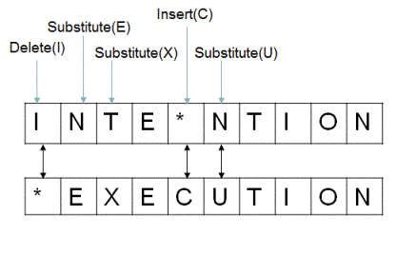
Credits for above example: Stanford University (https://web.stanford.edu/class/cs124)
Given two strings, write a program to find out the minimum edit distance between them.

Algorithm/Insights
The problem is not that difficult as it might appear to be when we break it down into smaller sub-problems and try to solve them.
Let the first string str1 of length 'm' be "A1A2A3 ... Am" where 'A1', 'A2' denote the individual characters of str1. Let the second string str2 of length 'n' be "B1B2B3 ... Bn". To compute the edit distance between these two strings, let's start comparing last characters of str1 and str2. If character 'Am' is equal to character 'Bn', then we just need to compute edit distance between strings "A1A2A3 ... Am-1" and "B1B2B3 ... Bn-1". But if the character 'Am' is not equal to character 'Bn' then we have got following three choices to use -
1. Insert character 'Bn' at the end of the string str1. Modified str1 would then look like "A1A2A3 ... AmBn". After this operation, we can now start computing edit distance between string "A1A1A2 ... Am" and "B1B2B3 ... Bn-1" because we don't need to consider last character 'Bn' of str2 which matches with newly inserted last character 'Bn' in str1. Notice how after performing insert operation on str1, we need to consider first 'm' characters of str1 and first 'n-1' characters of str2 for computing edit distance.
2. Delete last character 'Am' of str1 and compute edit distance between strings "A1A2A3 ... Am-1" and "B1B2B3 ... Bn". Notice that after performing delete operation on str2, we need to consider first 'm-1' characters of str1 and first 'n' characters of str2 for computing edit distance.
3. Substitute last character 'Am' of str1 by character 'Bn'. Now the modified str1 looks like "A1A2A3 ... Am-1Bn" and str2 is still "B1B2B3 ... Bn". After this substitute operation, we now need to compute edit distance between strings "A1A2A3 ... Am-1" and "B1B2B3 ... Bn-1". Notice that after performing substitute operation on str1, we now need to consider first 'm-1' characters of str1 and first 'n-1' characters of str2 for computing edit distance.
How do we decide which one of these three choices to use? Well, we can't decide that in advance and we need to try out all three choices and use the result of the choice which gives us minimum edit distance.
If we want to express above steps in a function call 'findEditDistance(String str1, String str2, int m, int n)' then that function would look like following -
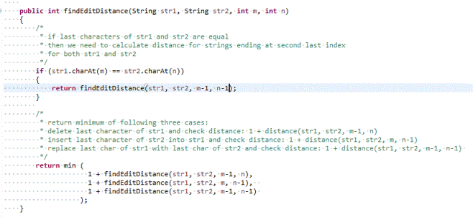
Now as you can observe, this function is recursive in nature and therefore we need to define base case for this recursion.
The base case would be -
1. If length of str1 is 0, then we need to insert all characters of str2 into str1 to make them equal. Therefore, edit distance between str1 and str2 when str1 is empty is length of str2.
2. If length of str2 is 0, then we need to delete all characters of str1 to make it equal to str2. Therefore, edit distance between str1 and str2 when str2 is empty is length of str1.
Please checkout function 'findDistance(String str1, String str2, int m, int n)' in code snippet for implementation details. The time complexity of above recursive algorithm is exponential since at every comparison step, we are making three choices making it roughly O(3^n) algorithm.
Dynamic Programming approach: Now let's see how we can optimize the time complexity of this algorithm. The partial recursion tree of call sequence for function findDistance(String str1, String str2, int m, int n) would look like following -
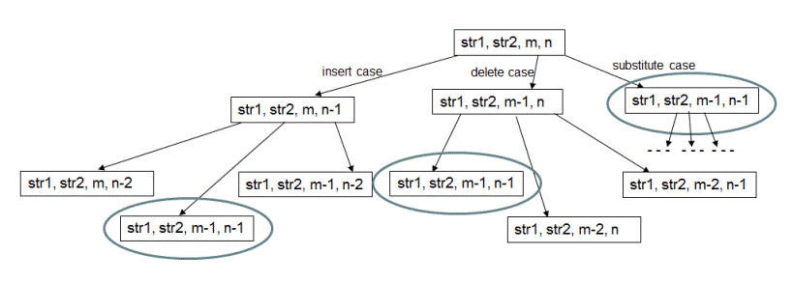
As highlighted above, there are function calls with same arguments which are being computed again and again. To avoid these redundant computations, we use dynamic programming based approach.
In this method, we use bottom up approach to compute the edit distance between str1 and str2. We start by computing edit distance for smaller sub-problems and use the results of these smaller sub-problems to compute results for sub-sequent larger problems. The results are stored in a two dimensional array as shown below.
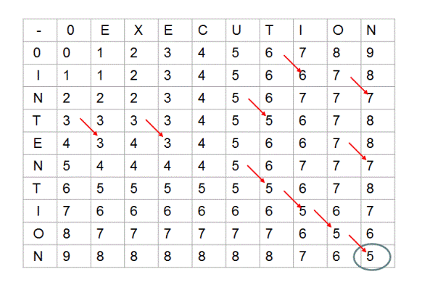
Each cell (m,n) of this array represents distance first 'm' characters of str1 and first 'n' characrers of str2. For example, when 'm' is 0, distance between str1 which is of 0 length and str2 of 'n' length is 'n'. Please observe 0th row of above matrix. Same is the case for values in 0th column where str2 is of 0 length.
Now in this matrix, for cell (m,n) which represents distance between str1 of length 'm' characters and str2 of length 'n' characters, if 'm'th character of str1 and 'n'th character of str2 are same, then we simply need to fill cell(m,n) using value of cell (m-1, n-1) which represents edit distance between first 'm-1' characters if str1 and first 'n-1' characters of str2. Notice the red arrows in the above array.
If 'm'th character of str1 is not equal to 'n'th character of str2, then we choose minimum value from following three cases-
1. Delete 'm'th character of str1 and compute edit distance between 'm-1' characters of str1 and 'n' characters of str2. For this computation, we simply have to do - (1 + array[m-1][n]) where 1 is the cost of delete operation and array[m-1][n] is edit distance between 'm-1' characters of str1 and 'n' characters of str2.
2. Similarly, for the second case of inserting last character of str2 into str1, we have to do - (1 + array[m][n-1]).
3. And for the third case of substituting last character of str1 by last character of str2 we use - (1 + array[m-1][n-1]).
Please checkout function 'findDistance(String str1, String str2)' in code snippet for implementation details. The time and space complexity of this method is O(mn) where 'm' is the length of str1 and 'n' is the length of str2.
public class EditDistanceStrings
{
final static int ERROR_INPUT = -1;

private int min(int a, int b)
{
return (a<b)?a:b;
}

private int min(int a, int b, int c)
{
return min(min(a,b),c);
}

public int findDistance(String str1, String str2, int m, int n)
{
// if either of the strings is null, distance cannot be computed
if (str1 == null || str2 == null)
{
return ERROR_INPUT;
}

// if str1 is an empty string, then insert all 'n' characters of str2 into str1
if (m == 0)
{
return n;
}

// if str2 is an empty string, then remove all 'm' characters of str1
if (n == 0)
{
return m;
}

/*
* if last characters of str1 and str2 are equal
* then we need to calculate distance for strings ending at second last index
* for both str1 and str2
*/
if (str1.charAt(m-1) == str2.charAt(n-1))
{
return findDistance(str1, str2, m-1, n-1);
}

/*
* return minimum of following three cases:
* delete last character of str1 and check distance: 1 + distance(str1, str2, m-1, n)
* insert last character of str2 into str1 and check distance: 1 + distance(str1, str2, m, n-1)
* replace last char of str1 with last char of str2 and check distance: 1 + distance(str1, str2, m-1, n-1)
*/
return min (
1 + findDistance(str1, str2, m-1, n),
1 + findDistance(str1, str2, m, n-1),
1 + findDistance(str1, str2, m-1, n-1)
);
}

public int findDistance(String str1, String str2)
{
// if either of the strings is null, distance cannot be computed
if (str1 == null || str2 == null)
{
return ERROR_INPUT;
}

// all values are by default initialized to 0 by JVM
int[][] distanceTable = new int[str1.length()+1][str2.length()+1];

int numRows = str1.length() + 1;
int numCols = str2.length() + 1;

for (int m = 0; m < numRows; m++)
{
for (int n = 0; n < numCols; n++)
{
// if length of str1 is 0, we have no option but to insert all of str2
if (m == 0)
{
distanceTable[m][n] = n;
}

// if length of str2 is 0, delete all of str1 to make it match with str2
else if (n == 0)
{
distanceTable[m][n] = m;
}

/*
* if last characters of str1 and str2 are equal, compute distance ending at
* second last characters for both str1 and str2
*/
else if (str1.charAt(m-1) == str2.charAt(n-1))
{
distanceTable[m][n] = distanceTable[m-1][n-1];
}

/*
* else use minimum of following three cases:
* delete last character of str1 and check distance: distance(str1, str2, m-1, n)
* insert last character of str2 into str1 and check distance: distance(str1, str2, m, n-1)
* replace last char of str1 with last char of str2 and check distance: distance(str1, str2, m-1, n-1)
*/
else
{
distanceTable[m][n] = min (
1 + distanceTable[m-1][n],
1 + distanceTable[m][n-1],
1 + distanceTable[m-1][n-1]
);
}
}
}

return distanceTable[numRows-1][numCols-1];
}

public static void main(String[] args)
{
EditDistanceStrings solution = new EditDistanceStrings();

System.out.print("minimum edit distance between \"intention\" and \"execution\" is: \n");
System.out.println(solution.findDistance("intention", "execution"));
}
}

Order of the Algorithm
Time Complexity is O(mn)
Space Complexity is O(mn)

Anagram Pattern Search
Given two strings 'pattern' and 'text', find whether any anagram of string pattern is a substring of text.
Example:
Input:
text = ideserve
pattern = veer
Output:
true
Substring which is an anagram of pattern: erve (ideserve)
public class LongestSubstringWithMUniqueCharacters {

public static String getLongestSubstringWithMUniqueCharacters(String s, Integer m) throws Exception {
int start = 0, end = 0, windowSize = 1, windowStart = 0;
int n = s.length();
HashMap<Character, Integer> hash = new HashMap<Character, Integer>();
char ch = s.charAt(0);
hash.put(ch, 1);

for (int i = 1; i < n; i++) {
ch = s.charAt(i);
if (!hash.containsKey(ch)) {
hash.put(ch, 1);
} else {
int temp = hash.get(ch);
hash.put(ch, ++temp);
}
end++;
// move start forward if number of unique characters is greater than m
while (!isLessThanM(hash, m)) {
int temp = hash.get(s.charAt(start));
hash.put(s.charAt(start), --temp);
start++;
}
if (end - start + 1 > windowSize) {
windowSize = end - start + 1;
windowStart = start;
}
}
return s.substring(windowStart, windowStart + windowSize);

}

public static boolean isLessThanM(HashMap<Character, Integer> hash, Integer m) {
int count = 0;
for (Character key : hash.keySet()) {
if (hash.get(key) > 0)
count++;
if(count > m) {
return false;
}
}

return true;
}

public static void main(String args[]) throws Exception {
System.out.println(getLongestSubstringWithMUniqueCharacters("karappa", 3));
}

